# A student forum for studying, similar to the “studforum”

Zhiyong Wang and Zijun Zhao

Actually people can do anything on the forum like second hand or asking for help

#### Basic

1 Forum can post topics with pictures, text 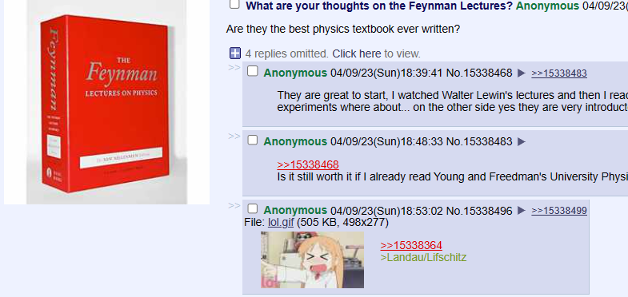

2 Have “like” function



3 Everyone can see it even it is not our students

4 We can save/star the posting/account/comment

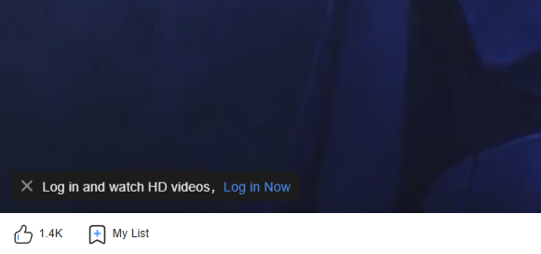

#### Some more function maybe we can do:

5 Mark the places like: ”I am in agora”



6 Comment other’s post

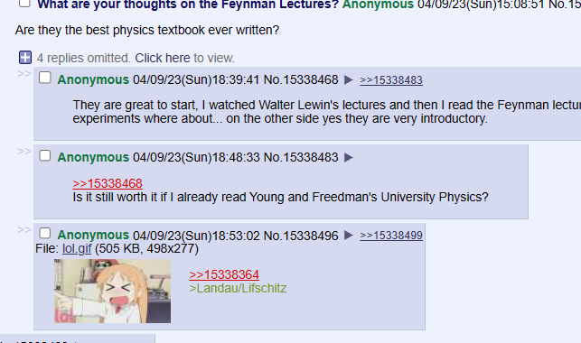

7 Add as a friend/follow



8 Upload some other kinds of file like pdf

9 Search



10 History

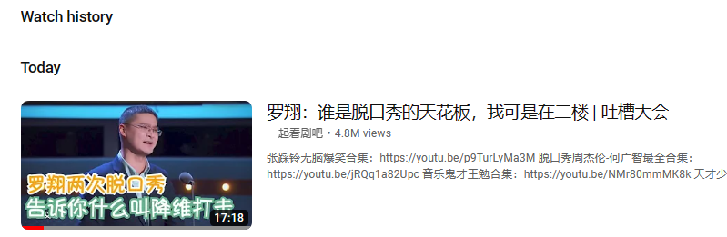

11 Account level like “kindergarden” to “professor”. First posting/get likes/share the post will gain experience



12 Vote for the answer

13 Groups like: groupT/VTK

